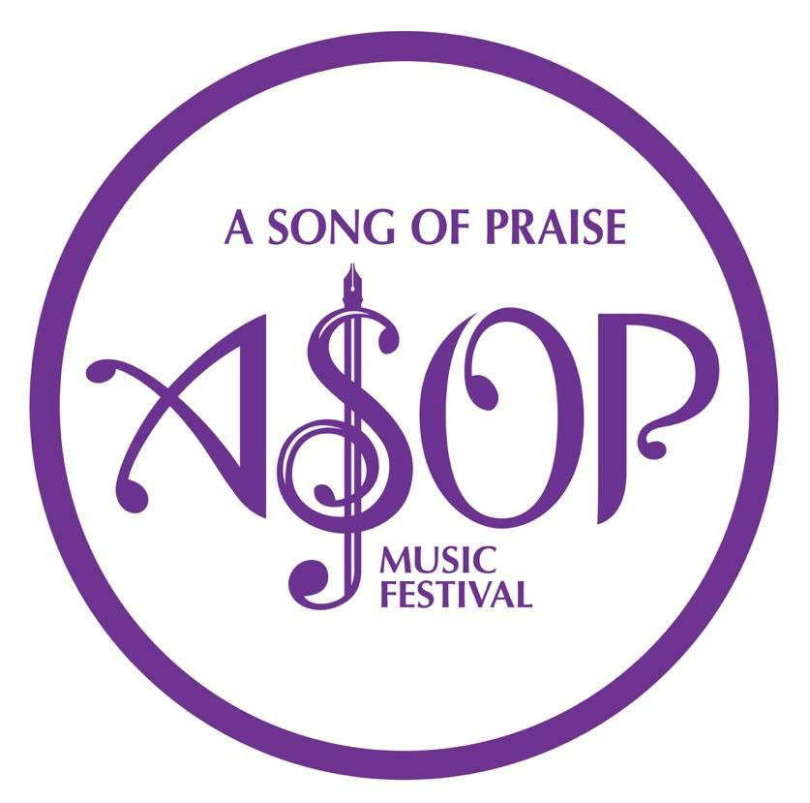

ASOP Music Festival Songwriting Competition

Contact number: +63 956-511-9991
E-mail: asopyr8.entries@gmail.com

A P P L I C A T I O N F O R M

REGION PROVINCE / CITY

APPLICANT’S NAME

ADDRESS

LANDLINE / MOBILE NOS. E-MAIL ADDRESS/ES

DATE OF BIRTH SONG ENTRY TITLE

NAME OF LYRICIST/S NAME OF ARRANGER/S

PERSON AND NUMBER TO CONTACT IN CASE APPLICANT IS UNAVAILABLE

I HEREBY CERTIFY THAT THE ABOVE SONG ENTRY:

(check all applicable)

Is my sole original work or the original work of all the
Composers / collaborators mentioned above.

Has not been previously recorded, released or commercially sold.

Has not been previously assigned to a third party.
AN INNOVATION BY UNTV 37 IN

COOPERATION WITH

_{2X2 PICTURE} BREAKTHROUGH AND MILESTONES PRODUCTIONS
INT’L. INC. (BMPI)

I FURTHER CERTIFY THAT:

- All the information I have supplied above is true of my own knowledge.

- I am joining the Contest on my own free will.

- No part of the Song Entry infringes on the copyright of any other work or in any way constitutes an infringement knowing it to be a deliberate offense or violation of the rights of third parties.

- I shall hold free and indemnify the ASOP-BMPI, ASOP Production Team, and its members and all other people involved in the Festival or Contest for any liability and damages arising out of the Song Entry above, whether awarded by final judgment or paid by way or amicable settlement.

- I have read and understood the Contest Rules and Regulations and agreed without any reservation to abide by them.

- I shall abide by the final decision of the Screening Committee and the Board of Judges.

SIGNATURE OF CONTESTANT/REPRESENTATIVE:

_____________________________________

Signature over Printed name

SIGNED IN THE PRESENCE OF:

_______________________________

Signature over Printed name

DATE: __________________

TO BE FILLED OUT BY SECRETARIAT

DATE RECEIVED: _______________ RECEIVED BY: __________________

ENTRY NUMBER

PROVINCE/CITY

A national songwriting competition to all amateur and
professional songwriters with the aim of providing venue for the

creation of songs of praise through collection of reflective thoughts, nurturing idea, blissful feeling of praises, and boundless musical prowess, all for the glory of God.

